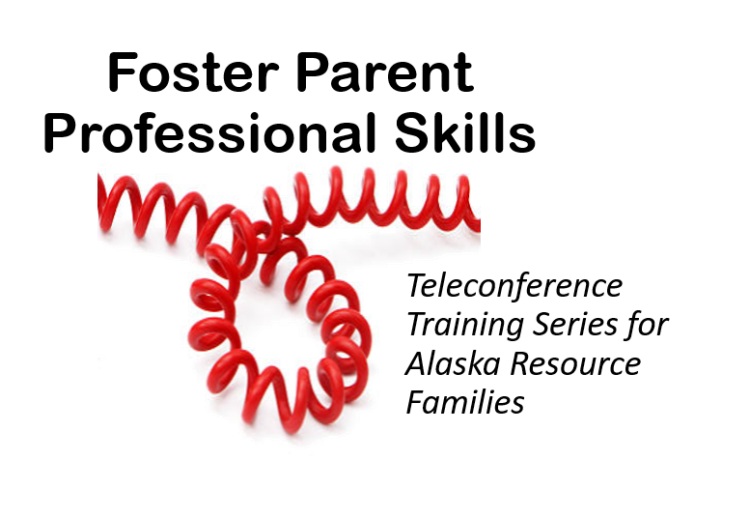
August 2023 to May 2024
To pre-register contact ACRF at 1-800-478-7307
To attend, call 1-800-944-8766, Participant Code 26867#
We are offering a series entitled Foster Parent Professional Skills to support the skills foster parents need to navigate the challenges of fostering and learn the importance of maintaining records.

BONUS: To build your toolkit, a set of documents or forms will accompany each session. Every family that attends multiple sessions has the opportunity to receive a binder with the printed documents and forms included. Stay tuned for more details.

Aug 16 (Wed) 12:00-1:00pm Investigations—Aileen McInnis, ACRF

Sept 20 (Wed) 12:00-1:00pm Recordkeeping, Mandated Reporting—Rachel Hanft, ACRF

Oct 18 (Wed) 12:00-1:00pm Financial Resources, Special Needs Unit—Maria VanOrd, ACRF

Nov 15 (Wed) 12:00-1:00pm Advocacy and Communication—Jodi von Brandt, ACRF

Dec 13 (Wed) 12:00-1:00pm Health, Medical Needs – Aileen McInnis, ACRF

Jan 17 (Wed) 12:00-1:00pm Educational Issues – Rachel Hanft, ACRF

Feb 12 (Wed) 12:00-1:00pm Family Contact – Jodi von Brandt, ACRF

Mar 20 (Wed) 12:00-1:00pm Reasonable and Prudent Parent Standard – Maria VanOrd, ACRF

Apr 17 (Wed) 12:00-1:00pm Transitions, Independent Living Skills

May 15 (Wed) 12:00-1:00pm ICWA (Indian Child Welfare Act)

The monthly Rural Teleconference is designed for anyone living outside of Anchorage, although anyone can participate. Families may participate by dialing 1-800-944-8766 and when asked, enter the code: 26867#. If you phone in before the group leader you will hear music, please stay on the line. Please call in 5 minutes early to give us your contact information so we can record your attendance, or stay on the line and speak to the facilitator after the teleconference ends.
Check the www.acrf.org teleconference training calendar prior to the teleconference for posted handouts or PowerPoints.

